First name (English)___________________________________________________

Last name _____________________________#_____HR Teacher_____________

***Spanish Study Guide Unit 2***

**A. Answer true or false. If it is false, correct the statement and make it true.**

1. __F___ In English, Cinco de mayo means April (May) 5th.

2. __F___ Cinco de mayo is not Mexico’s Independence Day.

3. __F___ Cinco de mayo is more popular and is celebrated more in (the U.S. than in Mexico) Mexico than in the United States.

**B. Please write Me gusta OR Me gustan in the blanks below if you like the following foods and drinks. Write No me gusta OR No me gustan if you don’t like them.**

1. (No) Me gusta_____________________________ el agua.

2 (No) me gustan__________________________las papas fritas.

3. (No) me gustan_______________________los tacos.

4. (No) me gusta________________________el café.

**C. Write the letter of the corresponding picture for the following foods:**

1.___a__ el pollo 2. __e___ el arroz

3._d____ las uvas 4. __f___ el bistec

5._b__ la manzana 6. __c___ los huevos

a. 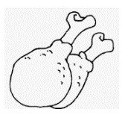 b.  c.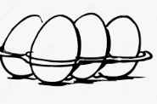 d.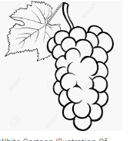 e.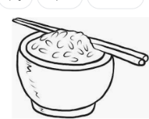 f. 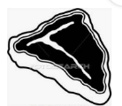

**D. Write the letter of the corresponding picture for the following body parts:**

1. ___b__ la mano 2. __f__ la nariz

3.__e__ la boca 4. __a_ los pies

5. __d__ la cabeza 6. __c__ los ojos

a.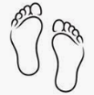 b.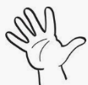 c.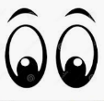

d.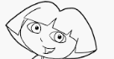 e. f.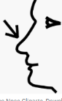

**E. Write the letter of the corresponding clock for the following times:**

1. __b__ Son las diez. 2. _a____ Son las cuatro.

3. _e_ Son las tres. 4. __f_ Es la una.

5. _d__Son las doce. 6. __c__ Son las cinco.

a.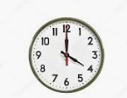 b.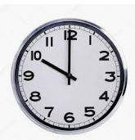 c. 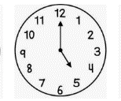

d.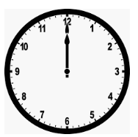 e. 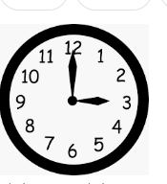 f. 